## **Title : SIMPLE SECIENTIFIC CALCULATOR**

## **Problem statement:**

To design and develop simple scientific calculator which allows user to perform operations.

## **Requirements:**

**Hardware requirements:**

* RAM:4GB and above
* Keyboard
* Intel core processor

**Software requirements:**

* Operating system: windows or mac
* Editor
* Programming language: C
* C Compiler

**Low level requirements**

* **RAM:** Size of the RAM plays a key role in performance.
* **Performance:** compare to simple calculator’s scientific calculator’s performance must be good.
* **Accurate:** scientific calculator must produce accurate output.
* **User friendly:** scientific calculators must be user friendly to increase the user interaction scientific calculators should provide user understandable results.

**High level requirements**

* Operating system must be required
* Library files must be supported
* User interface
* Keyboard which has digits and numbers

## 

## **Design:**

**Flowchart**

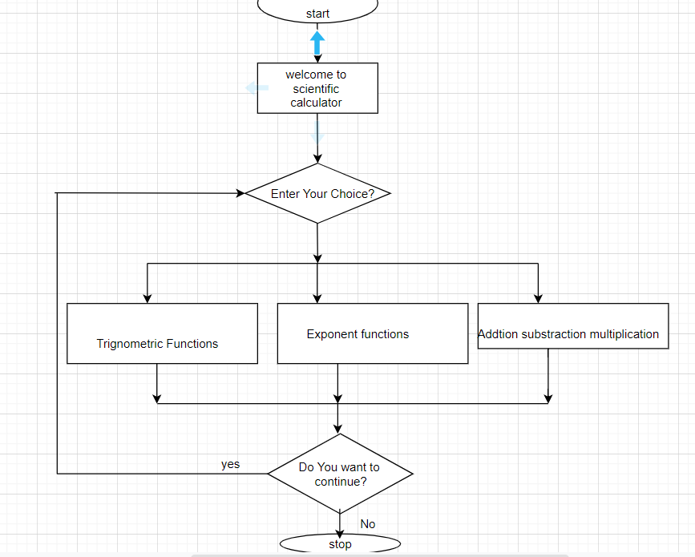

**Fig5: flowchart diagram for scientific calculator**

**Use case diagram**

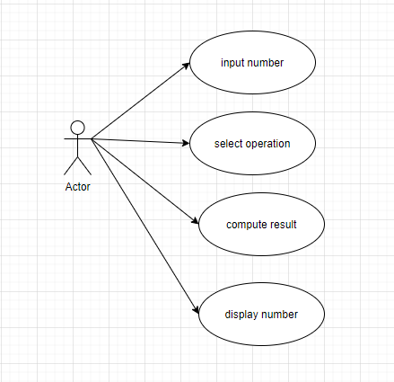

FIG6: usecasediagram for scientific calculator

**CLASS DIAGRAM FOR SCIENTIFIC CALCULATOR**

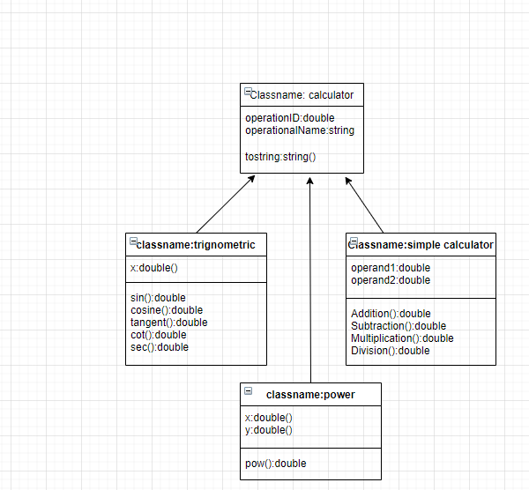

Fig7:classdiagram for simple scientific calculator

## 

## **Test plan**

**High level requirement test plan**

|  |  |  |  |  |  |
| --- | --- | --- | --- | --- | --- |
| ID | DESCRIPTION | PRECONDITION | EXPECTED INPUT | EXPECTED OUTPUT | ACTUAL OUTPUT |
| 1 | Addition operation check | Press addition operation | 2 inputs | Addition of 2 inputs | Addition of 2 inputs |
| 2 | Addition operation check | Select addition operation | wrong inputs | Addition of 2 inputs | Error |
| 3 | Subtraction check | Click on subtraction operation | 2 inputs | subtractions of 2 inputs | subtraction of 2 inputs |
| 4 | Subtraction check | Click on subtraction operation | wrong inputs | subtraction of 2 inputs | Error |
| 5 | Trigonometric functions check | Click on which trigonometric operation you need | Number input | Resulted Number | Correct result is produced |
| 6 | Logarithmic operations | Click on log operation | Input number to perform logarithm operation | Log of a number | log of input number |
| 7 | Factorial of a number | Click on factorial | Input number to calculate factorial | Factorial of a input number | Factorial of a input number |
| 8 | Exit | Click to exit | Select a displayed number to exit | exit | exit |

**Table4: High level requirement test plan**

**Low level Requirements**

|  |  |  |  |  |  |
| --- | --- | --- | --- | --- | --- |
| ID | DESCRIPTION | PRECONDITION | EXPECTED INPUT | EXPECTED OUTPUT | ACTUAL OUTPUT |
| 1 | Accuracy check | Correct and wrong inputs must be given | Correct input | Accurate result for the operations | Correct result |
| 2 | Accuracy check | Correct and wrong inputs must be given | wrong input | Accurate result for the operations | Correct result |
| 3 | Performance check | More number of operations should be selected | Many inputs | Give results fast and with accurate | Gives results fast and with accurate |
| 4 | Performance check | More number of operations should be selected | Many inputs  And many inputs | Give results fast and with accurate | Doesn’t Gives results fast and with accurate |

**Table5: Low level Requirements**